

iMM BizSoft Website Visual Design and Page Mockups
  - Module by module CAAI product strategy with brand integrated sample screens

Purpose Give designers developers product owners and content teams an implementable visual direction for the iMM BizSoft public website and CAAI product gateway.
Deliverable Sixteen branded desktop page mockups plus product strategy functional and technical guidance
Version 2.1
Date 23 September 2026
Status Internal design baseline for review and implementation

Important Third party screenshots are included only for internal design analysis. Their brands content imagery and layouts remain the property of their owners and must not be copied into the iMM BizSoft website.

Document control and design decision
Field | Direction
Design decision | Use a distinct iMM BizSoft design system. Borrow information architecture principles from the reference sites but do not reproduce their copy visual identity images or page composition.
Primary audiences | Chartered Accountant firms small and mid-size businesses finance teams company founders IT reviewers and existing customers.
Primary conversion | Product discovery followed by trial download demo or sales enquiry according to product maturity.
Core differentiation | Ease of use AI-driven assistance agentic orchestration reliable operation customer control of data and products that scale from a laptop to larger organisations.
Suite vision | CAAI ERP is the full suite for Chartered Accountants and their clients covering company registration financial accounting tax filing GST filing income tax filing client intake task scheduling and resource management.
Launch products | Company Registration and CAAI Financial Accounting are the completed independent products to be presented through the company website. The wider CAAI ERP suite remains the product roadmap.
Page coverage | Homepage product portfolio three product pages pricing download trust and security resources support about contact solutions index solution detail article and legal content template.
Excluded | Authenticated customer portal screens detailed desktop-product UX and unapproved claims that planned CAAI modules are already available.

Product strategy and release model
iMM BizSoft will release useful modules independently instead of delaying market entry until the entire CAAI ERP suite is complete. Completing every module before the first release is not a feasible delivery model for a startup because it concentrates time funding and execution risk before customer validation. Each released module must therefore solve a complete customer problem, operate independently, and connect to the wider suite through governed integration and agentic orchestration as those capabilities are delivered.
CAAI capability | Website status | Launch direction
Company Registration | Completed | Host as an available product with a guided enquiry or activation path.
Financial Accounting | Completed | Host as the first downloadable stand-alone product with trial subscription download backup and support journeys.
Client Intake | Planned | Show only in the suite roadmap until product acceptance is complete.
Task Scheduling | Planned | Show only in the suite roadmap until product acceptance is complete.
Resource Management | Planned | Show only in the suite roadmap until product acceptance is complete.
GST Filing | Planned | Show only in the suite roadmap and do not imply filing availability.
Income Tax Filing | Planned | Show only in the suite roadmap and do not imply filing availability.
Other Tax Filing | Planned | Use an extensible roadmap label until scope and statutory acceptance are approved.

How to use this document
- Product and leadership approve positioning page scope product status and commercial claims.
- Design uses the sample screens as a direction and converts them into a reusable responsive design system.
- Content owners replace illustrative copy numbers and release details with approved production content.
- Engineering implements the acceptance criteria and validates accessibility security performance and analytics before launch.
- Legal and security approve privacy registration statutory and trust statements before publication.

Contents
1 Reference website analysis
2 iMM BizSoft brand and visual direction
3 Site architecture and shared components
4 Page designs and sample screens
5 Responsive accessibility and performance
6 Content search and analytics
7 Technical architecture and security
8 Delivery and acceptance
9 Sources and usage notice

1 Reference website analysis
The reference review identifies patterns that help users understand a broad software portfolio. It is not a request to imitate trade dress. Screenshots were captured from publicly available homepages on 21 September 2026 and may change after that date.
Reference | Useful pattern | What iMM BizSoft should adopt | What to avoid
Zoho | Immediate suite positioning product discovery visible sign-up and privacy language. | A clear product chooser an ecosystem story and direct trial action. | Dense app catalogue multi-colour brand language and any copied wording.
Intuit | Strong audience-led hero recognised product family and support routes. | Human outcome-led messaging clear routes for accountants and businesses and visible sign-in. | Large promotional video dependence and US-specific consumer framing.
Intellect Design Arena | Enterprise navigation solution suites segments technology resources and contact sales. | Scalable portfolio navigation trust content resource taxonomy and enterprise contact path. | Banking-specific positioning visual imagery and enterprise complexity beyond launch needs.

Zoho homepage reference
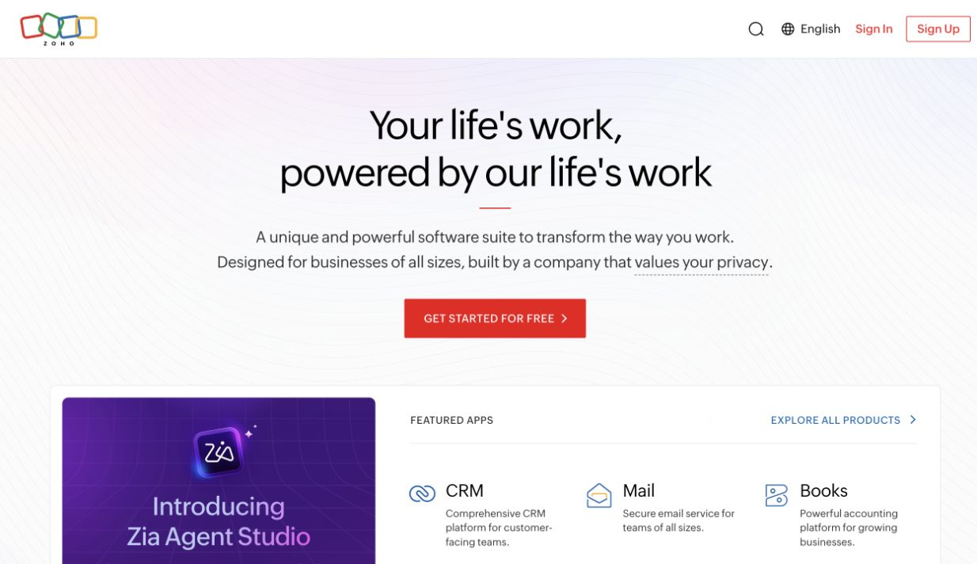
Zoho homepage reference
- Use a concise suite statement followed immediately by product discovery.
- Keep one dominant CTA and a clearly secondary exploration path.
- For iMM BizSoft limit the first view to three launch products rather than a large app catalogue.

Intuit homepage reference
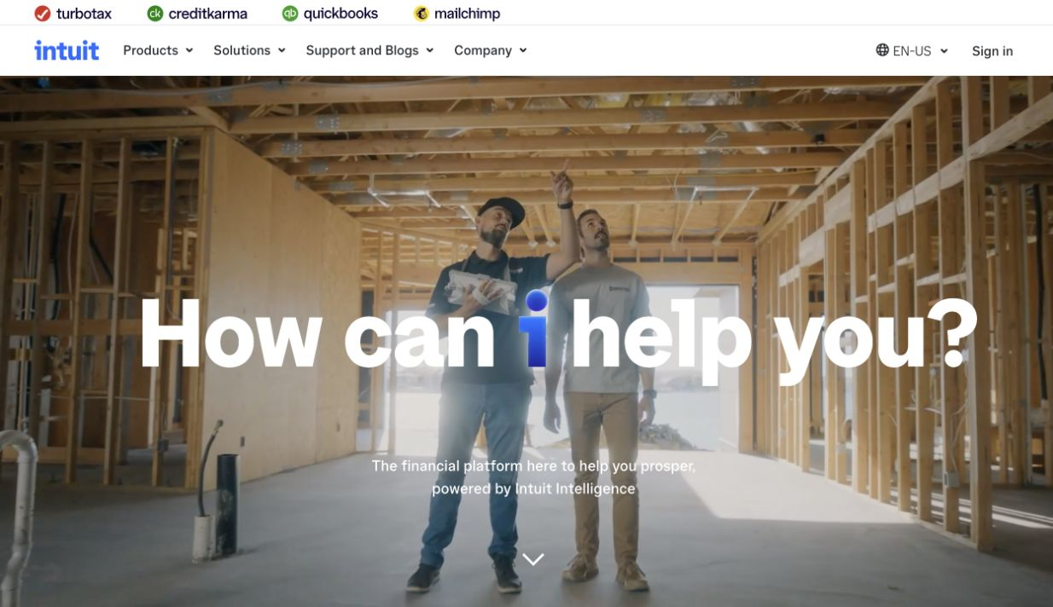
Intuit homepage reference
- Use role-based routes for Chartered Accountants small businesses and finance teams.
- Show the product family consistently in the global header.
- Use authentic product interfaces as primary proof instead of relying on promotional video.

Intellect Design Arena homepage reference
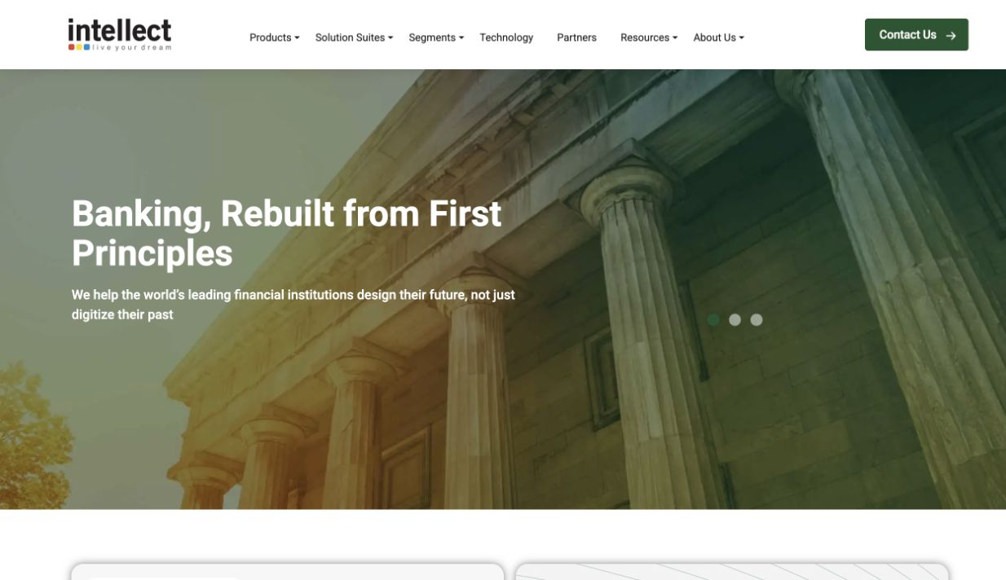
Intellect Design Arena homepage reference
- Use Products Solutions Resources Support and Company as durable navigation groups.
- Provide a clear enterprise contact action for Corporate and CA firm buyers.
- Keep launch navigation simpler than the reference until the portfolio expands.

2 iMM BizSoft brand and visual direction
The proposed design is calm precise and product-led. It uses the supplied iMM BizSoft corporate logo across the website and the supplied CAAI mark for the product suite and CAAI-branded modules. Deep navy communicates authority teal identifies actions and ample white space supports ease of use.

2.1 Brand roles
Brand asset | Role | Website use | Control
iMM BizSoft logo | Corporate and publisher identity | Global header footer company pages download publisher and legal pages. | Use the approved light or dark variant with clear space. Do not recolour distort or combine it with page titles.
CAAI suite mark | Product-suite identity | CAAI suite overview Company Registration Financial Accounting product cards and selected product hero areas. | Keep the detailed mark large enough to remain legible. Commission an approved simplified vector variant before using it as a favicon or very small navigation icon.
Product names | Offer identity | Use CAAI as the suite prefix where approved and keep Company Registration and Financial Accounting names consistent. | Show Available Completed Pilot or Planned in text rather than colour alone.

Element | Specification | Reason
Primary colour | Deep navy 102F46 | Financial credibility headings dark sections and footer.
Action colour | Teal 0B776E | Primary buttons links selected states and positive data.
Accent | Warm amber E39A24 | Warnings due items and limited emphasis never the only signal.
Neutral surfaces | White pale green F3F7F7 and light border D9D9D9 | Clean hierarchy and strong readability.
Typography | Inter Aptos or similar sans serif with a robust system fallback | Readable professional and suitable for English and Indian business terms.
Imagery | Real product UI authentic Indian business contexts approved customer evidence and the supplied CAAI suite mark | Builds trust while separating product identity from unsupported AI imagery.
Spacing | Wide desktop grid with restrained cards and generous vertical rhythm | Prevents the site from feeling like a dense accounting application.
Motion | Brief functional and reducible | Supports clarity and respects reduced-motion preferences.

2.2 Product experience principles
- Make common work easy to learn and complete without specialist product training.
- Design for dependable use by single-laptop small businesses and larger multiuser customers.
- Explain the outcome before the feature list.
- Show current product evidence before future vision.
- Identify Available Pilot Beta and Planned capability explicitly.
- Describe AI and agentic orchestration as governed assistance with explicit authority review and audit.
- Keep one primary action per section and never compete with three equal buttons.
- Use cards only for comparable choices such as products plans resources or support topics.
- Never imply statutory approval automatic compliance or autonomous accounting without validated scope.

2.3 Shared header and footer
Component | Desktop behavior | Mobile behavior
Global header | Supplied iMM BizSoft logo Products Solutions Pricing Resources Support Company Sign in and one Start free trial action. Sticky after scroll. | Corporate logo menu and one compact primary action. Menu traps focus and closes with Escape.
Product submenu | Current product status audience and main pages. | Accordion groups with all links available by keyboard.
Footer | Products solutions support company legal contact and India region marker. | Single-column accessible link groups with clear headings.
Breadcrumb | Present below header on deep pages and included in structured data. | Wrap naturally and maintain a minimum touch target.
Search | Visible in Resources and Support and available globally as the library grows. | Full-screen labelled search with recent or suggested topics.

3 Site architecture and shared components
Top level | Included routes | Primary action
Products | All Products CAAI ERP Suite Company Registration Financial Accounting | Explore suite roadmap start registration enquiry or trial accounting
Solutions | For CA Firms For Small Businesses For Finance Teams | Explore matched products
Pricing | Trial Single User Multiuser Corporate definitions and FAQ | Start trial choose plan or contact sales
Resources | Guides checklists product updates webinars security and articles | Read download or register
Support | Help search getting started workflows backup licensing downloads contact | Solve issue or create support request
Company | About contact partners later careers later | Start a conversation
Trust and legal | Security privacy responsible AI accessibility terms licence cookies | Review evidence or policy

3.1 Shared components
- Hero with eyebrow heading supporting copy one primary CTA one optional secondary CTA and authentic product proof.
- Product card audience card plan card resource card release item FAQ and proof metric.
- Tabs only when the alternatives are few and all content remains addressable and keyboard operable.
- Forms with persistent labels instructions error summary consent and a clear success state.
- Download component with version date OS architecture size publisher checksum release notes and signature help.
- Status badges with text plus colour for Available Pilot Beta Planned Stable and Unsupported.

4 Page designs and sample screens
The following screens are original iMM BizSoft concepts created for this specification. They translate reference-site patterns into a distinct design and should be implemented as reusable responsive templates rather than fixed images.

4.1 Homepage
Purpose Explain the full-suite vision while moving visitors to the two completed independent products.
Reference influence Zoho product discovery Intuit outcome-led hero and Intellect scalable navigation. The final screen is an original iMM BizSoft design.
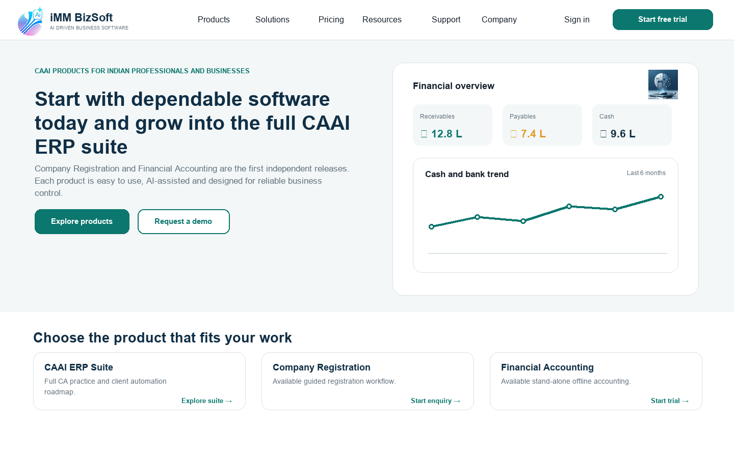
4.1 Homepage sample screen
- Keep the first view to one promise two actions and one authentic product interface.
- Show the CAAI suite roadmap separately from available Company Registration and Financial Accounting actions.
- Do not publish customer logos or performance numbers until evidence is approved.

4.2 Products index
Purpose Let a visitor understand what is available now and how it fits the future suite.
Reference influence Zoho suite navigation and Intuit product-family grouping. The final screen is an original iMM BizSoft design.
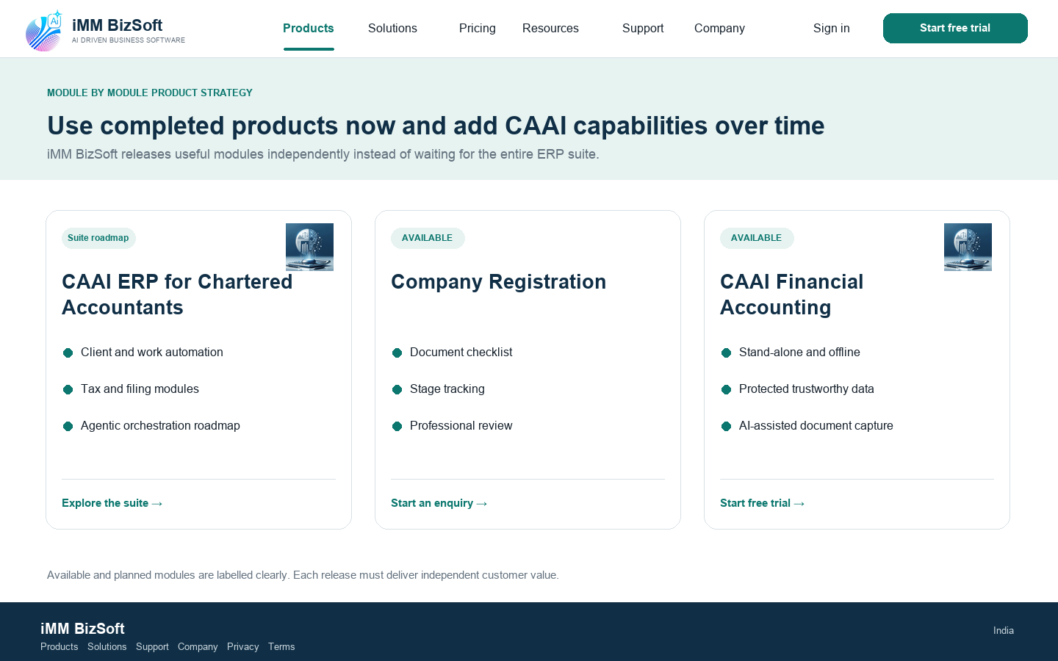
4.2 Products index sample screen
- Use a consistent comparison structure for audience outcome capabilities and CTA.
- Planned products appear separately and never use an active purchase action.
- The template must accept a fourth product without redesign.

4.3 CAAI ERP suite for Chartered Accountants
Purpose Explain the long-term CAAI vision without delaying or overstating the independently released products.
Reference influence Intuit accountant route and Intellect enterprise solution architecture. The final screen is an original iMM BizSoft design.
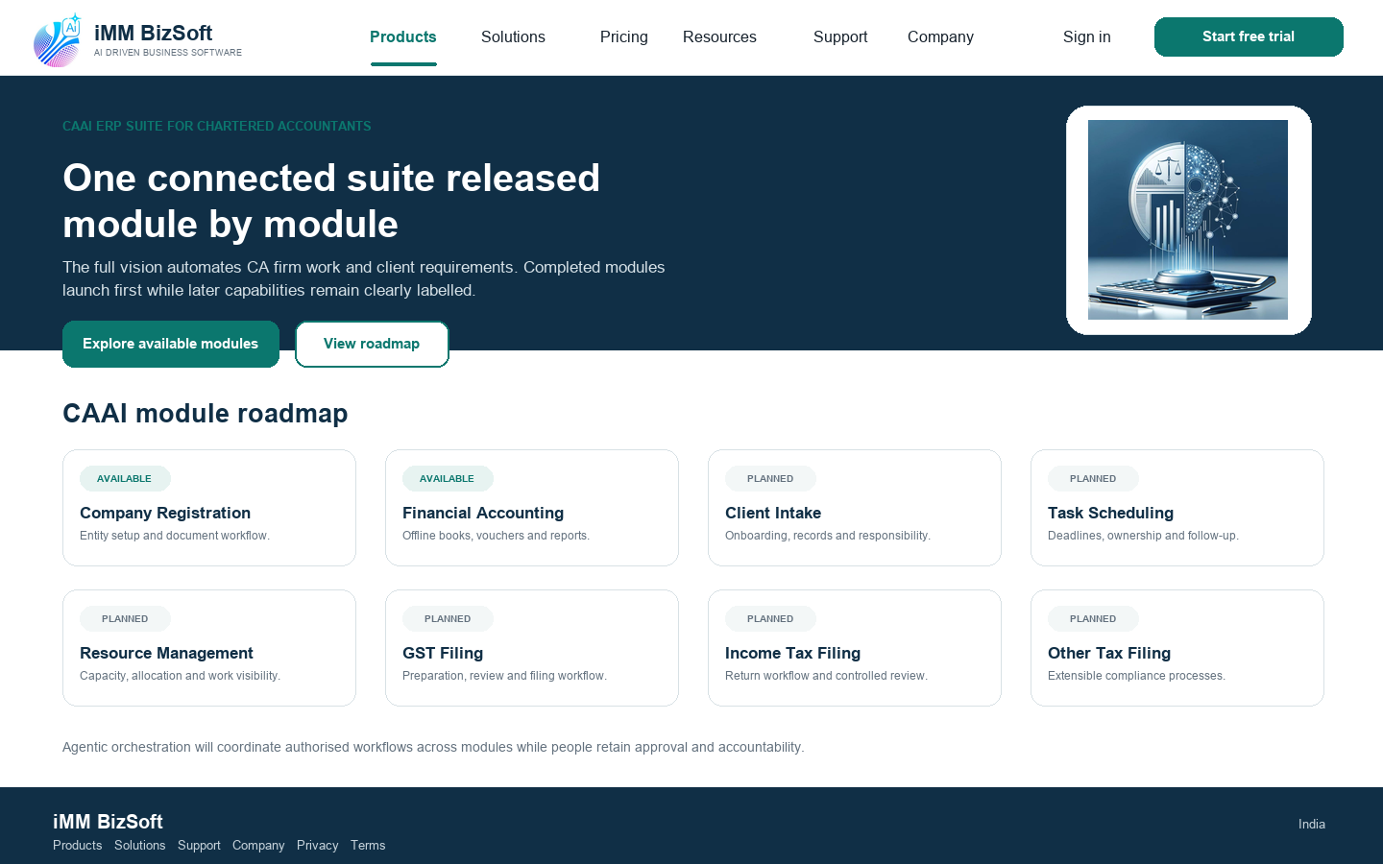
4.3 CAAI ERP suite for Chartered Accountants sample screen
- List Company Registration and Financial Accounting as the completed modules to be hosted through the website.
- List client intake task scheduling resource management GST income tax and other tax filing as planned until accepted.
- Explain that agentic orchestration coordinates authorised workflows and does not remove professional accountability.

4.4 Company Registration
Purpose Help founders understand the process and submit a qualified enquiry.
Reference influence Intuit step-led journey and Zoho clarity of product entry. The final screen is an original iMM BizSoft design.
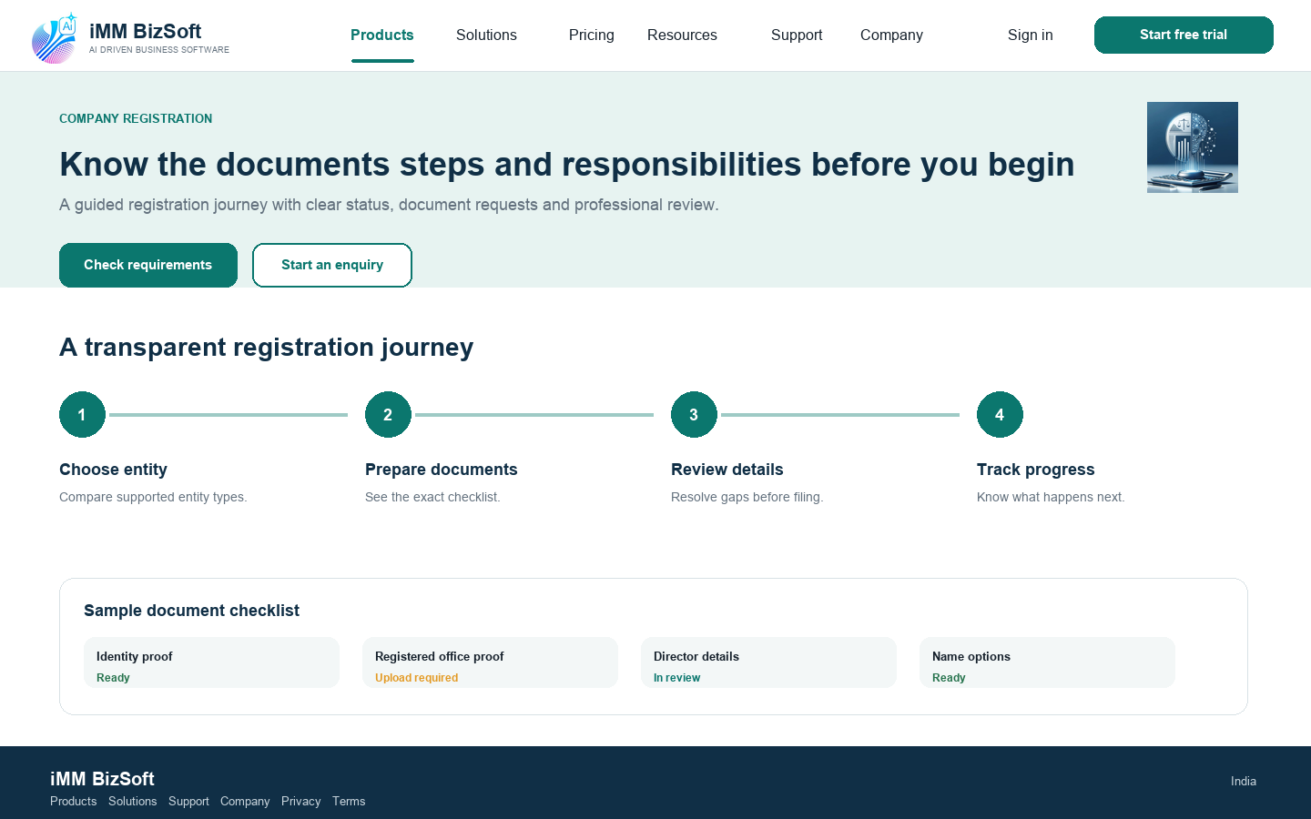
4.4 Company Registration sample screen
- Confirm whether the offer is software managed service or combined before publishing.
- State customer and professional responsibilities and use dated checklists.
- Never imply government affiliation or guaranteed approval.

4.5 CAAI Financial Accounting
Purpose Move small businesses from evaluation to trial or download.
Reference influence Zoho Books product clarity and Intuit QuickBooks audience focus. The final screen is an original iMM BizSoft design.
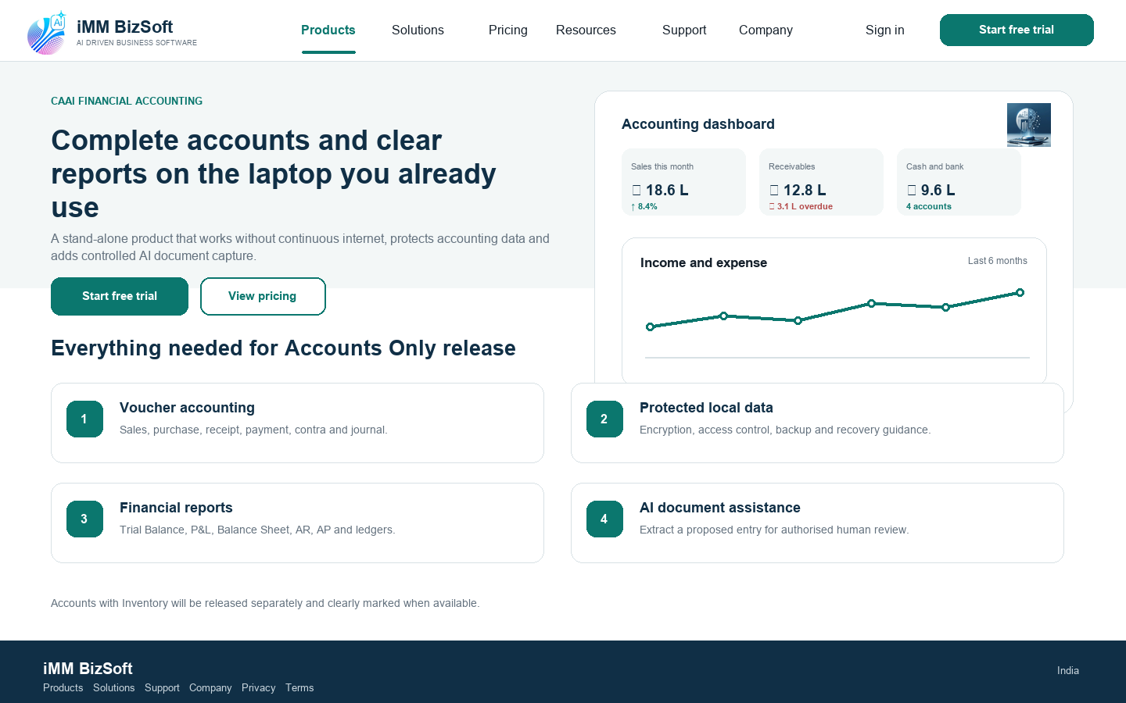
4.5 CAAI Financial Accounting sample screen
- State that normal accounting works without continuous internet and list online exceptions.
- State local encryption access control backup and recovery behavior using approved evidence.
- Show Accounts Only as available and Inventory as a later release until approved.
- Explain AI document processing as a proposed entry requiring authorised review.

4.6 Pricing
Purpose Make the trial Single User Multiuser and Corporate choices understandable before purchase.
Reference influence Zoho plan comparison and Intuit audience-specific conversion. The final screen is an original iMM BizSoft design.
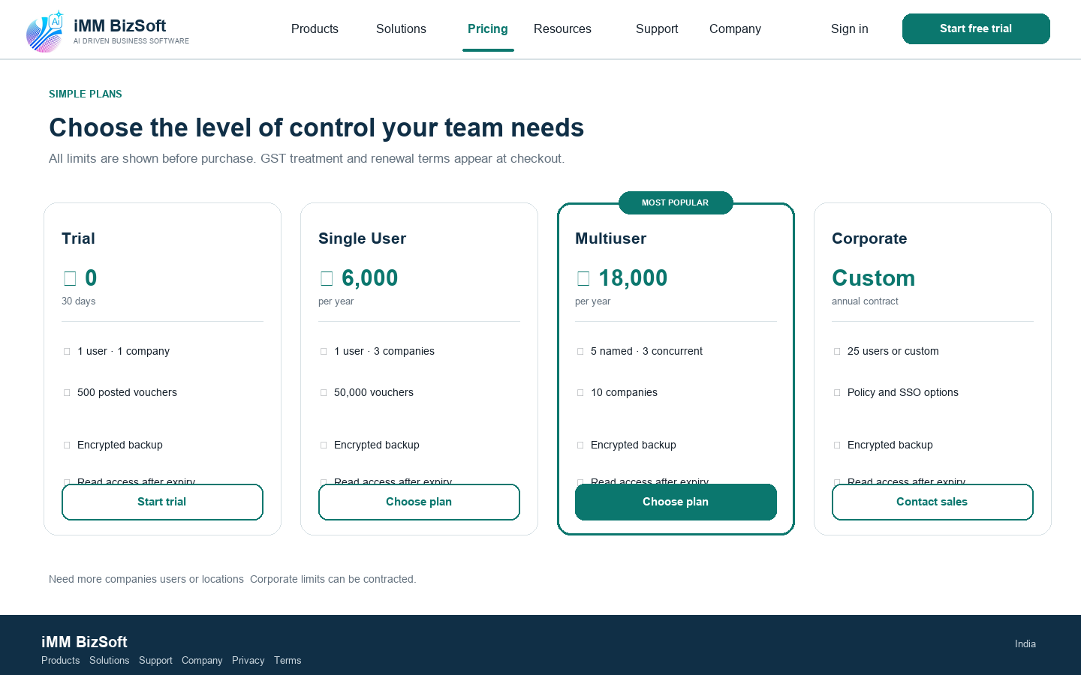
4.6 Pricing sample screen
- Define named user concurrent user company and posted voucher directly below the plans.
- Display GST treatment billing period renewal cancellation and post-expiry access.
- All price and limit content comes from one commercial source of truth.

4.7 Download centre
Purpose Give customers a safe official software-download route.
Reference influence Intellect resource discipline and enterprise trust patterns. The final screen is an original iMM BizSoft design.
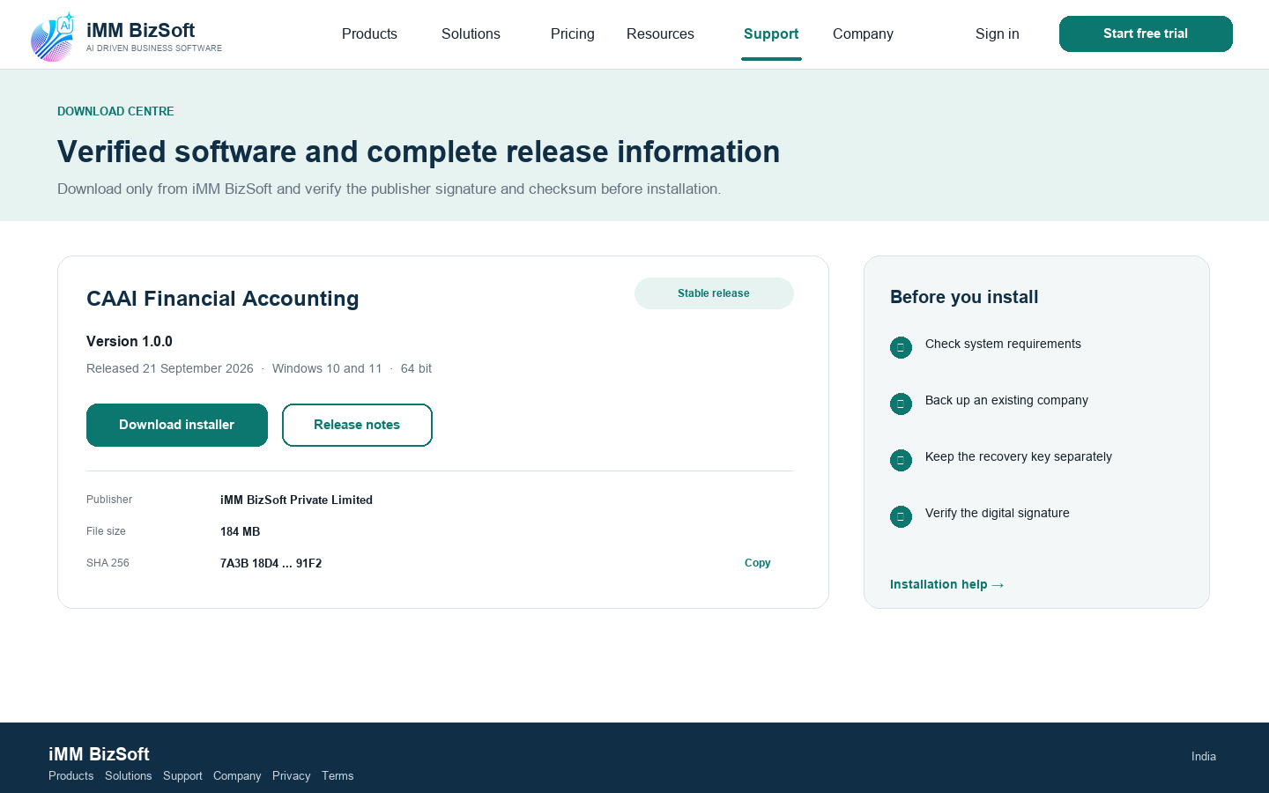
4.7 Download centre sample screen
- Never publish a package without version date support status publisher and checksum.
- Link release notes system requirements signature verification and known issues.
- Customer download must not require marketing consent.

4.8 Trust security and responsible AI
Purpose Answer IT customer and procurement concerns with scoped evidence.
Reference influence Zoho privacy values Intuit trust framing and Intellect enterprise technology positioning. The final screen is an original iMM BizSoft design.
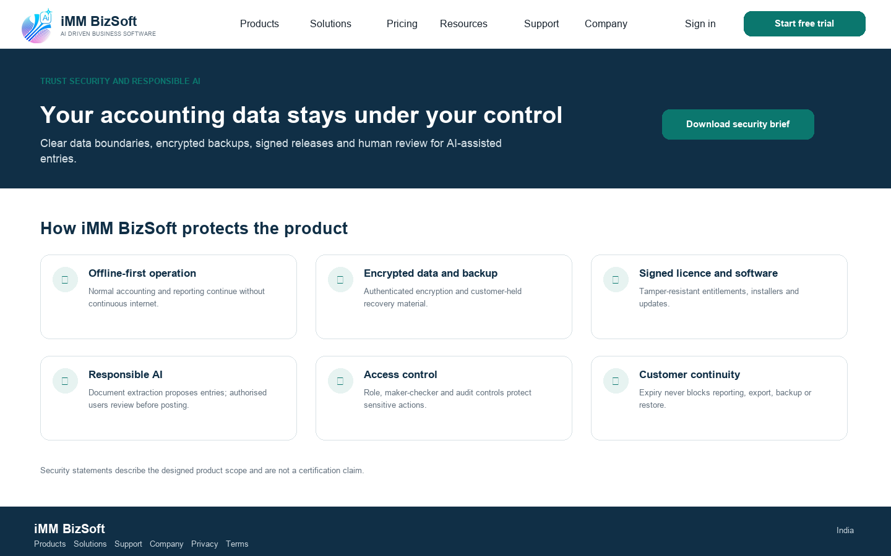
4.8 Trust security and responsible AI sample screen
- Every claim names scope owner evidence version and review date.
- Separate designed controls from independently certified controls.
- Link the security brief privacy notice vulnerability contact and responsible-AI statement.

4.9 Resources library
Purpose Build trust support organic discovery and product education.
Reference influence Intellect resource taxonomy plus Intuit support and blog access. The final screen is an original iMM BizSoft design.
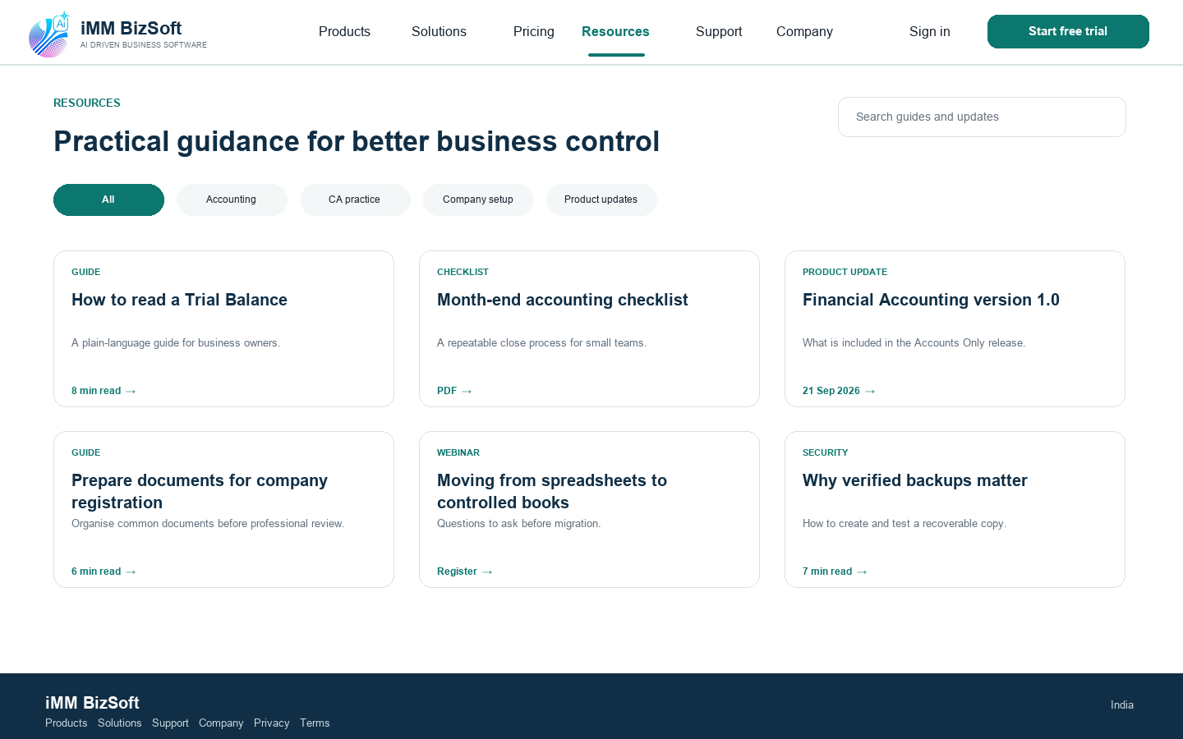
4.9 Resources library sample screen
- Each resource has author reviewer date topic product and review-by date.
- Statutory and registration content requires qualified review and visible date.
- Avoid thin AI-generated pages made only for search traffic.

4.10 Support gateway
Purpose Help existing customers solve common issues quickly.
Reference influence Intuit support-first routing and Zoho product help patterns. The final screen is an original iMM BizSoft design.
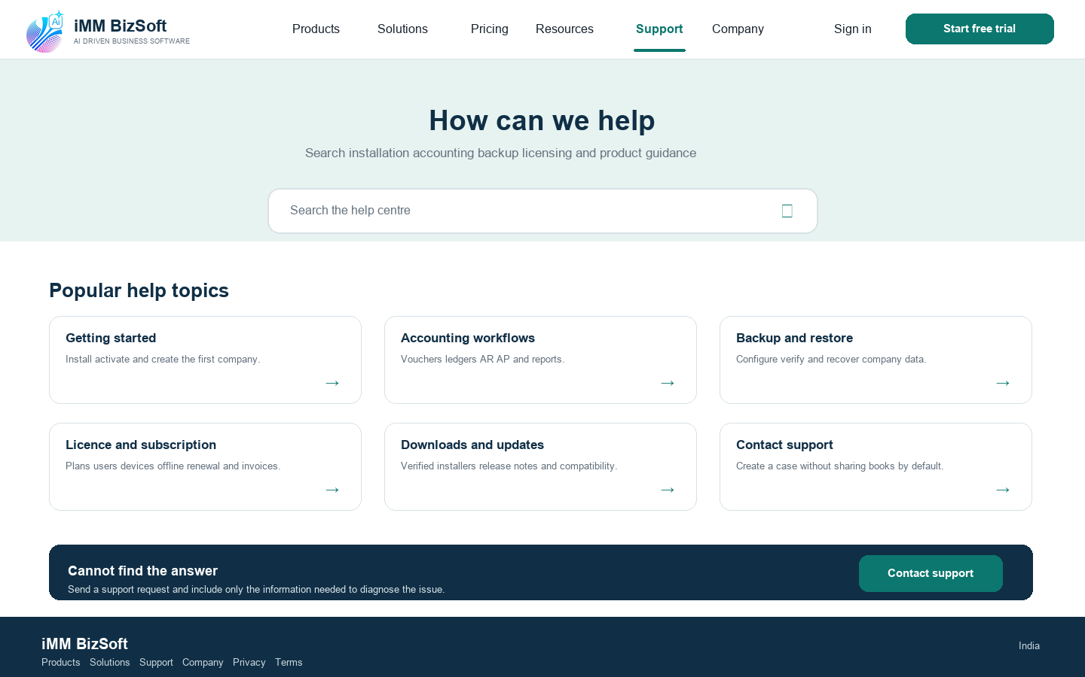
4.10 Support gateway sample screen
- Search covers approved public documentation only.
- The support form does not request accounting books or documents by default.
- Expose service status downloads releases and system requirements.

4.11 About iMM BizSoft
Purpose Establish a credible Indian software company behind the products.
Reference influence Zoho values narrative and Intellect corporate credibility. The final screen is an original iMM BizSoft design.
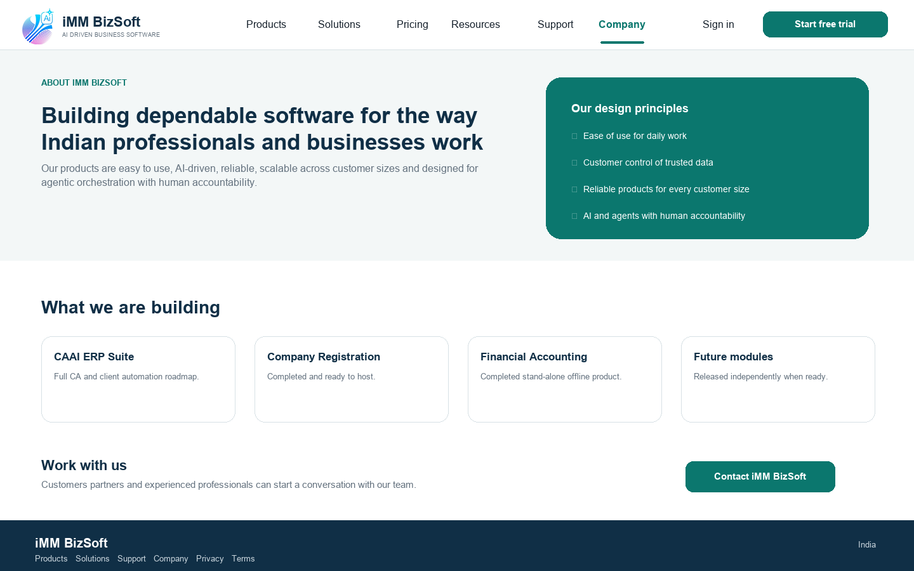
4.11 About iMM BizSoft sample screen
- Use verified leadership company and location facts only.
- Replace generic claims with evidence such as product releases support commitments and approved customer proof.
- Keep the portfolio current as products are introduced.

4.12 Contact
Purpose Send each enquiry to the correct owner with minimal friction.
Reference influence Intellect visible contact action and Intuit route-by-need behavior. The final screen is an original iMM BizSoft design.
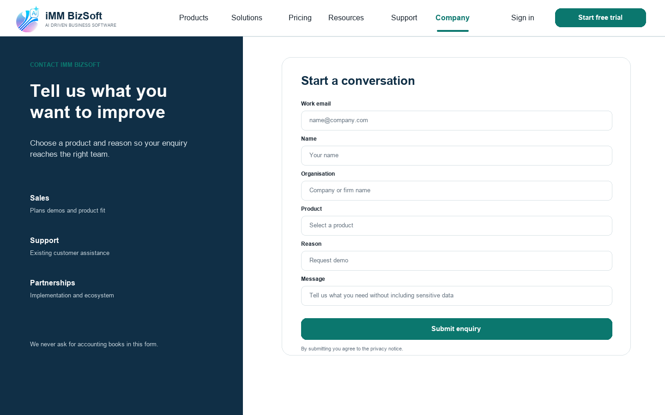
4.12 Contact sample screen
- Collect product reason organisation contact and consent but no accounting data.
- Show expected response time only after operations approves it.
- Confirmation explains what happens next and provides a reference number.

4.13 Solutions index
Purpose Help a visitor who knows the problem but not the product.
Reference influence Intellect solution suites and segments plus Intuit audience navigation. The final screen is an original iMM BizSoft design.
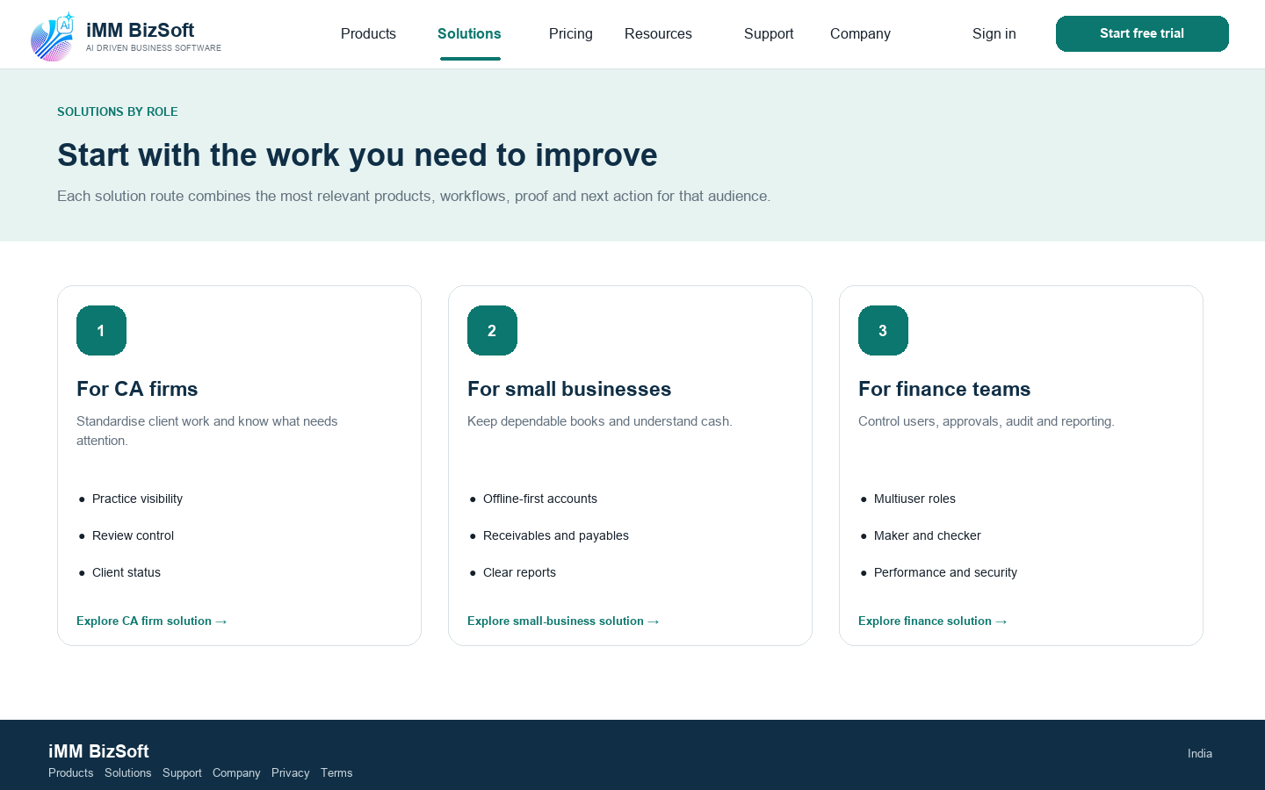
4.13 Solutions index sample screen
- Each solution maps outcomes to existing products rather than inventing a separate product.
- Use the same three comparison dimensions across audiences.
- Add new audiences through the CMS schema.

4.14 Solution detail
Purpose Connect a business problem to the minimum suitable product and next step.
Reference influence Intuit role-specific narrative and Intellect solution architecture. The final screen is an original iMM BizSoft design.
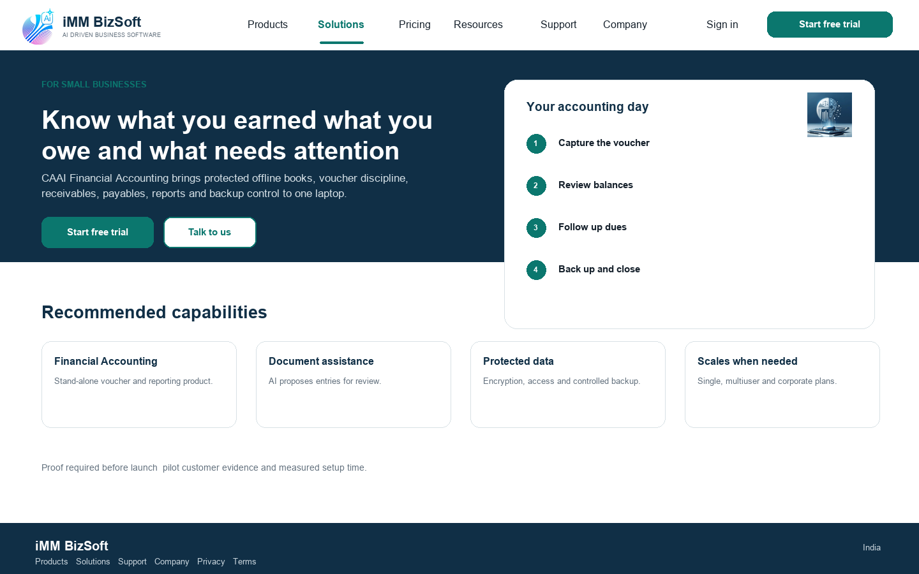
4.14 Solution detail sample screen
- Lead with the work sequence not internal module names.
- Use proof and product status before conversion.
- Link to the product pricing security and trial route.

4.15 Resource article
Purpose Provide trustworthy educational content that can be maintained over time.
Reference influence Intuit blog and support discoverability plus Intellect thought-leadership organisation. The final screen is an original iMM BizSoft design.
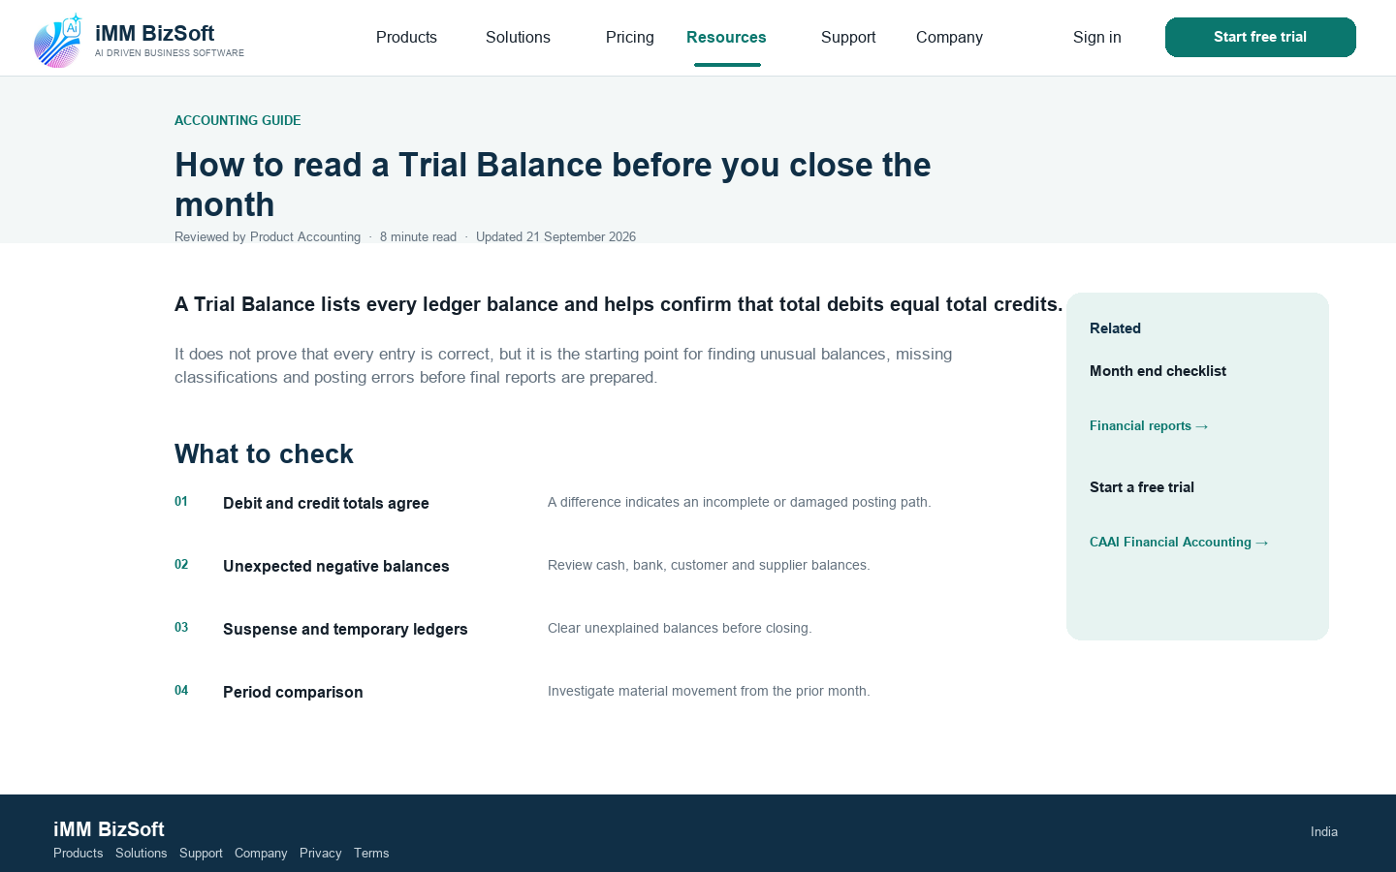
4.15 Resource article sample screen
- Use one H1 logical headings references and an updated date.
- Identify subject-matter reviewer for accounting legal security or regulatory content.
- Keep the product CTA relevant and secondary to the answer.

4.16 Legal content template
Purpose Make privacy terms accessibility cookies and licence information readable and governed.
Reference influence Zoho privacy prominence and Intuit corporate-policy access. The final screen is an original iMM BizSoft design.
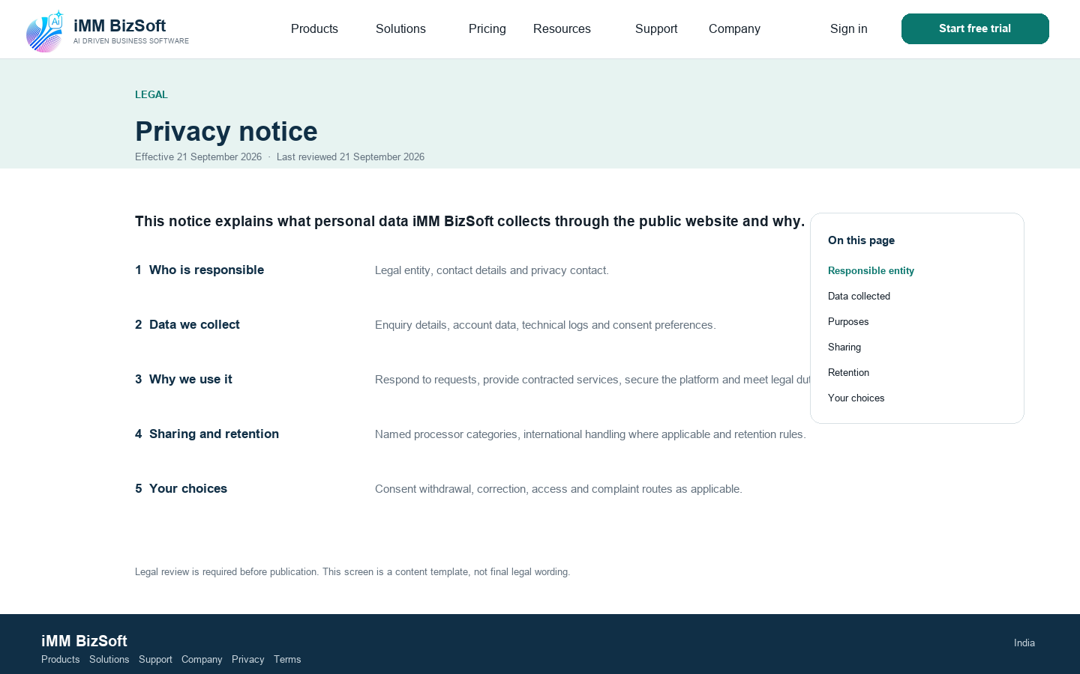
4.16 Legal content template sample screen
- Final wording comes from qualified legal review not the mockup.
- Provide version history contact and effective date.
- The page remains usable without non-essential cookies or scripts.

5 Responsive accessibility and performance
Area | Acceptance
Responsive | Critical journeys work at 320 CSS pixels through large desktop without content loss or horizontal page scrolling.
Keyboard | All navigation menus controls filters forms accordions dialogs and media are operable with visible focus and no trap.
Screen reader | Landmarks heading order labels errors statuses table headers and alternatives communicate the same meaning as the visual design.
Zoom and reflow | Content works at 200 percent zoom; sticky elements do not obscure focus or content.
Contrast and motion | WCAG 2.2 AA contrast; no colour-only meaning; reduced motion is respected.
LCP | Largest Contentful Paint at or below 2.5 seconds at the 75th percentile.
INP | Interaction to Next Paint at or below 200 milliseconds at the 75th percentile.
CLS | Cumulative Layout Shift at or below 0.10 at the 75th percentile.
Weight | Initial mobile homepage or product page at or below 1.5 MB with a target of 800 KB excluding streamed video.

5.1 Mobile transformation
- Header becomes a labelled menu with a compact primary action and focus containment.
- Three and four-column card layouts stack to one column; plans use summaries plus an accessible comparison view.
- Hero copy loads before media and the CTA remains visible without becoming a persistent obstruction.
- Tables used for releases or plans expose a meaningful stacked mobile alternative.
- Touch targets and spacing meet WCAG 2.2 requirements and form keyboards match input purpose.

6 Content search and analytics
Content object | Required governance fields
Product | Name slug status audience summary outcomes capabilities media CTA plan links evidence owner and review date.
Solution | Audience problem outcomes products proof CTA owner and review date.
Plan | Name price tax treatment billing period entitlements exclusions support effective dates and approver.
Release | Product version channel date files signature publisher checksums notes support status and owner.
Resource | Type title summary author reviewer dates topic product references CTA and expiry/review date.
Claim | Exact wording evidence source product/version geography approval effective date and review date.
Legal page | Owner approvers effective date review date version history contact and jurisdiction.

6.1 Search and SEO
- Server-render indexable HTML unique titles descriptions canonicals sitemap robots and correct status codes.
- Structured data for Organisation SoftwareApplication Product Breadcrumb Article and FAQ only when visible content qualifies.
- Topic clusters include financial accounting software India offline accounting accounting for small business software for CA firms company registration workflows voucher accounting backup and audit.
- Use descriptive internal links between product solution guide FAQ pricing download security and support.

6.2 Funnel measurement
Stage | Events | KPI
Discovery | Product select audience select search and navigation | Homepage to product or solution rate
Evaluation | Feature pricing system requirement security FAQ and release interaction | Evaluation completion rate
Intent | Trial download demo contact and support starts | Intent rate by product and audience
Conversion | Verified trial download demo and enquiry completion | Conversion rate and qualified leads
Support | Search article helpful contact start and ticket completion | Self service success rate

Analytics shall not contain contact details free text licence keys accounting data document content or other sensitive information.

7 Technical architecture and security
Layer | Recommended design | Key control
Presentation | Component framework with static generation and server rendering TypeScript and reusable design system. | Semantic HTML route-level performance budgets and dependency controls.
Content | Headless CMS with structured types preview workflow scheduling audit and roles. | Editor and approver separation MFA and stale-content reporting.
Delivery | CDN image optimisation compression caching TLS and WAF. | Secure headers controlled origin monitoring and rollback.
Forms | Server-side validation rate limit bot protection consent record and CRM/helpdesk handoff. | No third-party secrets in browser and no sensitive accounting-data prompts.
Identity | Customer portal on a separate authenticated subdomain and release boundary. | Separate cookies CSP sessions and privileged access.
Downloads | CDN/object storage with signed installer manifest release metadata and checksum. | Code signing malware scan controlled release and integrity verification.
Product integration | Versioned local-first product interfaces and a governed orchestration layer as modules are released. | Explicit user authority least privilege signed messages audit trails and graceful offline behavior.
Analytics | Consent-aware first-party event layer and privacy-minimised reporting. | Field allowlist retention and no free-text capture.
Operations | Source control CI/CD preview staging production monitoring and rollback. | Protected branch security scans release approval and audit.

7.1 Security requirements
- TLS HSTS restrictive Content Security Policy frame protection nosniff referrer and permissions policies.
- Server-side validation output encoding CSRF controls rate limiting bot defence and safe upload handling where enabled.
- CMS and operations access require MFA least privilege audit and prompt security patching.
- Dependency secret and malware scanning software bill of materials and protected production release.
- Privacy notice consent preferences retention processor register and a current Indian legal review.
- Incident response credential and key rotation content rollback vulnerability handling and customer communication runbooks.

8 Delivery and acceptance
Phase | Deliverables | Exit criteria
1 Foundation | Approve brand IA page templates design tokens CMS schema claims process technical platform and measurement. | Leadership Product Design Engineering Security and Legal approval.
2 Launch pages | Homepage suite overview Company Registration Financial Accounting solutions pricing about contact security and legal. | Completed products are clearly separated from roadmap modules and all responsive accessibility content security SEO and performance gates pass.
3 Customer gateway | Downloads releases system requirements support search resources and portal handoff. | Signed download and existing-customer journeys pass end to end.
4 Growth | Customer proof webinars audience landing pages content clusters and experiments. | Governed publishing and funnel dashboard operate with approved evidence.
5 Expansion | Additional products partners localisation and integration content. | New product launches through existing templates without navigation rebuild.

8.1 Page template acceptance matrix
ID | Template | Acceptance evidence
WEB-001 | Homepage | Approved content and claims complete; responsive keyboard screen-reader SEO analytics security performance and link tests pass.
PRD-001 | Products and product detail | Approved content and claims complete; responsive keyboard screen-reader SEO analytics security performance and link tests pass.
SOL-001 | Solutions | Approved content and claims complete; responsive keyboard screen-reader SEO analytics security performance and link tests pass.
PRI-001 | Pricing | Approved content and claims complete; responsive keyboard screen-reader SEO analytics security performance and link tests pass.
DWN-001 | Downloads | Approved content and claims complete; responsive keyboard screen-reader SEO analytics security performance and link tests pass.
TRU-001 | Trust and security | Approved content and claims complete; responsive keyboard screen-reader SEO analytics security performance and link tests pass.
RES-001 | Resources and article | Approved content and claims complete; responsive keyboard screen-reader SEO analytics security performance and link tests pass.
SUP-001 | Support | Approved content and claims complete; responsive keyboard screen-reader SEO analytics security performance and link tests pass.
COM-001 | About and contact | Approved content and claims complete; responsive keyboard screen-reader SEO analytics security performance and link tests pass.
LEG-001 | Legal | Approved content and claims complete; responsive keyboard screen-reader SEO analytics security performance and link tests pass.

8.2 Launch decisions still required
- Confirm legal rights production master files clear-space rules and accessible alternatives for the supplied iMM BizSoft and CAAI brand assets.
- Approve exact product names availability status screenshots supported features and roadmap labels.
- Approve pricing plan limits GST treatment trial renewal cancellation and refund language.
- Decide whether Company Registration is software managed service or a combined offering.
- Approve privacy terms cookie licence accessibility and responsible-AI wording.
- Provide signed production packages checksums release notes system requirements and support ownership.
- Provide genuine customer proof or hide proof sections until approved evidence exists.

9 Sources and usage notice
The following public sites were reviewed for navigation product discovery audience routing trust content and conversion patterns. Links point to the source homepages reviewed on 21 September 2026.
Zoho — suite positioning product discovery free-start path and privacy messaging.
Intuit — product family audience routes support access and outcome-led hero.
Intellect Design Arena — product and solution navigation segments resources enterprise trust and contact route.
WCAG 2.2 — accessibility requirements with Level AA as the target.
Core Web Vitals thresholds — LCP INP and CLS field-performance targets.
OWASP Application Security Verification Standard — testable application-security baseline.
Digital Personal Data Protection Act 2023 — India privacy baseline subject to current legal advice and rules in force.

9.1 Screenshot and trademark notice
The Zoho Intuit and Intellect Design Arena screenshots are limited excerpts captured for internal comparative design analysis. All third-party trademarks imagery copy and website designs belong to their respective owners. iMM BizSoft shall publish only original design assets licensed content and approved claims.

